

Field Test Case of a Southwest China Photovoltaic Base

Flir T540 Solves 10 Major Operation & Maintenance Challenges in One Go
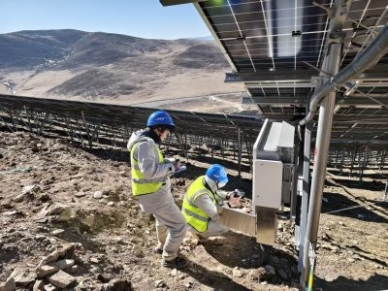
China is investing in photovoltaic (PV) installations at a rapid pace and becoming a core market, holding more than 40% of global capacity. While the future of PV power generation is promising, the industry faces significant challenges: intermittency, output fluctuations, poor accuracy, high operational risks, and the inefficiencies that come with traditional operations and maintenance (O&M). All of these barriers risk hindering industry development.

Many companies are turning to infrared imaging technology as a tool to help them overcome these challenges. Thermal imaging cameras such as the Flir T540 are invaluable for predictive maintenance at large-scale power generation facilities. In fact, an 80 GW integrated hydro-wind-solar base in southwest China employed the T540 with a dual field-of-view lens to successfully address major O&M issues.
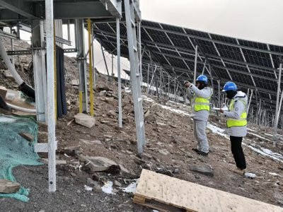

Core Application Scenario: Full-Chain Coverage for Power Plant O&M
The Flir T540 professional infrared thermal camera, paired with the FlexView dual field-of-view lens, is a powerful tool for PV O&M. Without manual lens replacement, it enables instant switching between a 24° standard FOV and a 14° telephoto FOV, ensuring efficient and precise fault localization.

Based on on-site conditions and with thermal imaging in their toolkit, the O&M team developed a “proactive prevention” strategy that balances inspection efficiency and accuracy while significantly reducing O&M costs and time.

Module Inspection: Locating Faults in Core Power-Generating Units Hot-Spot Effect Detection

Issues such as shading, damage, or diode failure all appear as hot-spot areas with >5°C temperature difference through a thermal imaging camera. The Flir T540 accurately identifies these zones, enabling repairs within 24 hours and preventing 20%–50% power loss.

Micro-crack and Cold-Solder Detection
Micro-cracks or cold-solder joints create linear or mesh-like low-temperature patterns (~1°C difference). The T540 captures these subtle defects, enabling repairs within 72 hours and extending module lifespan.

PID Degradation Detection
PID causes stripe-shaped high-temperature zones along module edges. The T540 clearly reveals these patterns, allowing resolution within 7 days to prevent further degradation.

Equipment Inspection: Ensuring Stable Operation of Critical Devices
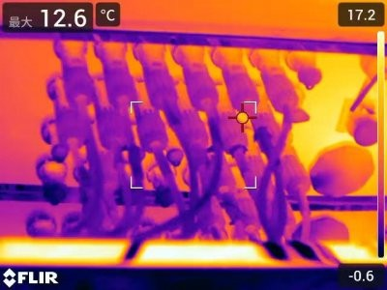

Inverter and Transformer-Box Inspection
Overheating points on heat sinks and terminals are all detectable through thermal imaging, preventing equipment burnout and improving conversion efficiency by 3%–5%.
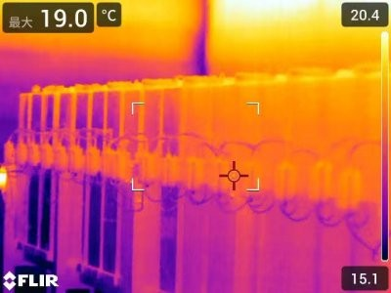

Battery Bank Inspection
The T540 detects localized overheating or abnormal temperature rise, preventing performance degradation or damage.

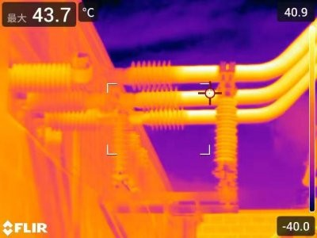

Insulated Busbar Inspection
Poor contact or insulation aging early can be detected on the T540, preventing short circuits or fire hazards.
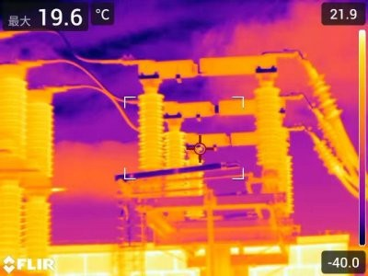

SVG and Incoming Cables
Abnormal temperature rises in SVG power modules, reactors, and cable joints can be caught early, preventing degradation and downtime.
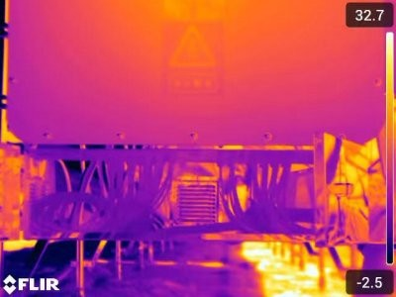

Safer Inspections
With the dual FOV lens, the T540 enables users to detect short-circuits early while operating the camera from a safe distance.

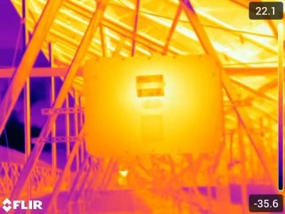

Support Structure and Mechanical Inspection
Temperature anomalies caused by deformation or loose components are revealed with thermal imaging, enabling timely adjustment to reduce power loss.
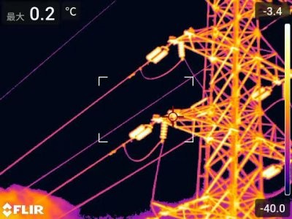

Transmission Line Inspection
Hotspots caused by poor contact or overload on transmission lines can be easily identified for repair.

From the real-world case above, it is clear that the Flir T540 professional infrared thermal camera, combined with the FlexView dual field-of-view lens, reshapes the PV operation and maintenance system. By enhancing power generation efficiency, reducing O&M costs, strengthening safety risk control, the T540 drives the industry toward a “proactive prevention” model through technological integration and scenario expansion—ultimately enabling high-quality development.

ABOUT FLIR, A TELEDYNE TECHNOLOGIES COMPANY
FLIR, a Teledyne Technologies company, is a world leader in intelligent sensing solutions for industrial applications with thousands of employees worldwide. Founded in 1978, the company creates advanced technologies to help professionals make better, faster decisions that save lives and livelihoods. For more information, please visit www.teledyneflir.com or follow @flir.

