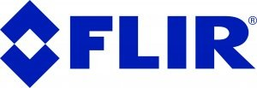

FULLY CONNECTED WITH FLIR IXX: ONTERRIS DELIVERS FASTER INSPECTIONS, BETTER ACCURACY, REAL SAVINGS

By combining advanced thermal imaging with workflows directly connected to the company’s moisture assessment platform, Onterris (formerly CTEH) has reduced moisture mapping costs by upwards of 40% while improving accuracy and speed.
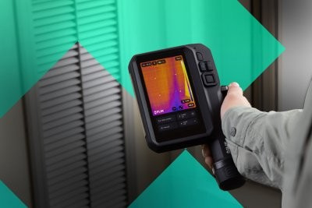
By combining advanced thermal imaging with workflows directly connected to the company’s moisture assessment platform, Onterris (formerly CTEH) has reduced moisture mapping costs by upwards of 40% while improving accuracy and speed. The Flir iXX Series enables faster inspections, real-time collaboration, and more efficient data integration, transforming both field performance and client delivery.

Operating across the United States, Canada and Australia, the Onterris Resilience and Recovery Team specializes in helping return buildings to safe, functional conditions after issues such as water damage, contamination, or environmental hazards. Their teams handle a wide range of building science challenges from indoor air quality and ventilation assessments to disaster response, chemical impacts, and post-remediation verification. A key element of this work is the need to quickly understand what’s happening inside structures, often under time pressure and in complex environments. Moisture migration, hidden damage, and contamination risks must be identified early to ensure effective remediation and reduce long-term costs.
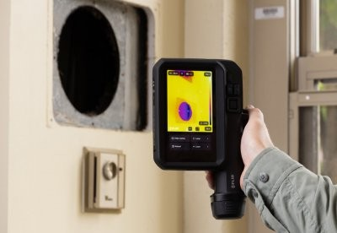

Thermal Imaging and Structured Workflows in Practice
Thermal imaging is a key part of Onterris’ inspections, helping teams quickly spot temperature differences that reveal moisture paths, hidden leaks, and other issues not visible to the eye. It also supports airflow checks, identification of potential biological growth, and detection of chemical leaks. Combined with moisture meters, hygrometers, and iPads running the company’s proprietary Moisture Assessment Survey Tool (MAST®) along with LiDAR scanning and integrated data capture, this setup allows teams to efficiently map conditions, document findings, and deliver clear, client-ready reports that support remediation decisions.

Choosing the iXX-Series
Before adopting the Flir iXX Series, Onterris used a mix of Flir Ex and Cx-Series cameras. The move to iXX was driven by the need for higher accuracy and field efficiency, enabling teams to reliably detect even subtle issues, work comfortably through long inspections, and efficiently cover larger or elevated areas. Key selection criteria included:
- High-resolution imaging for better anomalydetection
- Ease of use and ergonomics for long days in the field
- Open API compatibility to integrate directly with internal software
- Built-in teleconferencing capabilities for real-time expert support
The ability to connect thermal images directly with the company’s MAST® platform was particularly valuable, eliminating manual steps and reducing the risk of errors.

Immediate Impact: Faster, More Accurate, and More Cost-Effective
The transition to the iXX Series has delivered measurable improvements across operations:
- Average cost per square foot reduced by upwards of 40%
- Improved detection accuracy, with fewer overlooked areas
- Reduced downtime thanks to longer battery life
This translates to more efficient inspections and better outcomes for clients, without increasing operational complexity. In practice, the iXX cameras have helped Onterris identify problem areas earlier and with greater confidence, increase responder productivity in the field, simplify training and deployment, and deliver more consistent and reliable inspection results. The cost reduction alone demonstrates how improved imaging capability and seamless data integration can directly impact profitability and scalability.

Tangible Benefits and Future Direction
The expansion of the iXX across Onterris has been driven by clear, practical advantages, strengthening both operational efficiency and brand reputation and positioning the business for continued growth. These include:
- Immediate access to expert input via live communication
- Higher-quality deliverables for clients
- Reduced need for follow-up analysis after site visits
This allows teams to resolve issues faster and with greater confidence, while improving overall client satisfaction. The adoption of the iXX-Series has also delivered benefits beyond field performance, improving team morale and confidence in equipment, enabling faster turnaround times for clients, and providing stronger data quality and reporting.
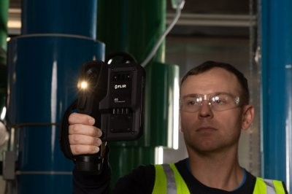

Looking ahead, the biggest opportunity is deeper digital integration: automatically linking thermal images to inspection data, reducing manual work and errors, and speeding up reporting. The iXX already supports this with built-in connectivity, enabling real-time collaboration and faster decisions on-site. Future enhancements, such as automatic logging of environmental and psychrometric data with each thermal image, and consolidation of tools into a more integrated inspection ecosystem could further streamline workflows. These improvements would continue to reduce equipment load while increasing data quality and usability.

To learn more about how Onterris works to protect human health and the environment, visit Onterris.com

ABOUT FLIR, A TELEDYNE TECHNOLOGIES COMPANY
FLIR, a Teledyne Technologies company, is a world leader in intelligent sensing solutions for industrial applications with thousands of employees worldwide. Founded in 1978, the company creates advanced technologies to help professionals make better, faster decisions that save lives and livelihoods. For more information, please visit www.teledyneflir.com or follow @flir.

