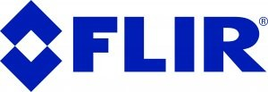

From outer perimeter to inner rack: Flir as the end-to-end reliability partner across data center operations

For a data center operator, risk rarely comes down to a single system or department
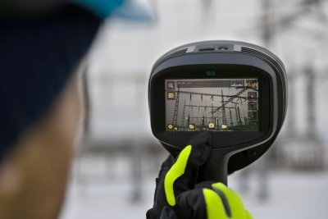
For a data center operator, risk rarely comes down to a single system or department. It can begin with a cut fence, an intruder approaching a substation, an alarm no one trusted enough to investigate, or a rack that ran hot overnight. The cause may be different, but the consequence is often the same: an interruption to operations that can be costly. More than half of significant data center outages can now cost a company over
$100,000, and roughly one in five exceed $1 million, according to the Uptime Institute's 2024 Annual Outage Analysis.

The challenge is that the industry tends to sell protection the way it is organized internally: one function at a time, with perimeter security pitched to the Security Director, substation protection routed to facilities, and rack thermal monitoring and inspection left to reliability engineering. A VP of Operations, however, is responsible for uptime across the entire site, making the fence and the rack part of the same operational risk conversation.

Reliability, not another security line item
Perimeter detection, electrical monitoring, alarm management, and rack inspections may fall under different departments, but they all serve the same basic purpose: identifying problems early enough to prevent them from affecting operations.

A perimeter breach, for example, often begins as a security event. If the intruder reaches a substation or other critical equipment, it quickly becomes an uptime issue. Security may investigate the incident, but the operational impact will be measured by lost capacity, service disruption, and recovery time. Bringing these controls into a single program gives operators a more complete view of the risk they manage. It also helps reduce the gaps that appear when each department plans, purchases, and operates its systems independently.
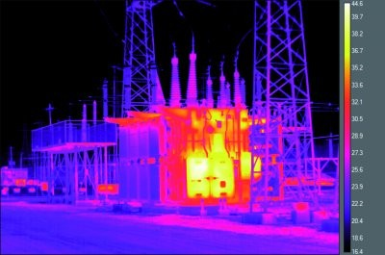

Following the risk from the fence inward
At the outer edge of a property, data centers can stretch for miles of dark, lightly staffed perimeter. Much of that darkness is by design. Many sites are built as low-light facilities to avoid adding light pollution to the surrounding area, which is good for neighboring communities but leaves conventional cameras with little to work with. Thermal imaging removes that dependency, reading the heat signature of a person or vehicle in complete darkness. Detecting movement early matters because the farther a potential threat travels into the site, the less time an operator has to assess and respond.

The solution can be a multilayered security approach, beginning with a radar system such as the Flir
R-190/R-290 detecting movement as it approaches or crosses the perimeter. It works in concert with both the bi-spectral FH-Series AI thermal/visible cameras and the bi-spectral Elara DX-Series thermal/visible PTZ cameras to verify the activity and continue tracking it. Instead of relying on a single sensor or an isolated alarm, the operator receives multiple sources of information that help determine whether the event requires action.

Those detections can feed into Flir Latitude VMS, giving the control room a common view of the event. Flir Nexus® connects sensors and systems so that information gathered at the fence reaches the person responding.

Moving deeper into the property, the substation is one of the most important points of exposure. The equipment feeding power to the data halls is essential to the operation, yet it is often less visible than the systems inside the building.

Fixed radiometric thermal cameras can continuously monitor transformers, electrical connections, and other energized equipment for abnormal temperature changes. While technicians could miss a loose or deteriorating connection during a visual inspection, an infrared camera detects the heat it produces well before the equipment fails. That allows the operations team to investigate and make repairs during a planned maintenance window rather than responding after an outage.

Inside the data hall, the available response time becomes even shorter. GPU-dense racks can draw several times the power of the traditional 8 to 12 kW rack, creating more heat in a smaller space. Under those conditions, a cooling issue or component failure that developed over several days could escalate within minutes.

Periodic handheld inspections also play an important role, as they allow maintenance teams to view assets from multiple angles and distances. Fixed thermal monitoring provides visibility between scheduled surveys, while handheld tools with route-based inspection capabilities, such as the Flir i65 and Assetlink software, support more detailed inspections, analysis, and documentation when a potential issue is identified. Onboard tools such as reference imaging ensure these handheld inspections result in repeatable, trackable thermal data, making it easier to identify changes over time and support repair decisions. When combined with safety equipment such as infrared windows, maintenance teams can help maintain uptime by safely inspecting energized electrical equipment.

Two budgets, one operational problem
Security and operations are often managed separately, leading different teams to purchase thermal technology for different purposes. The security department may invest in thermal cameras for perimeter protection, while the operations team deploys thermal equipment for electrical inspections, early fire detection, and rack monitoring. Although these purchases are often made independently, they address closely related risks.

Simply put: the purchases come from different budgets because the organization is divided that way. The risk itself is not.

Grand View Research valued the data center physical security market at $1.87 billion in 2023 and projects it will reach $4.83 billion by 2030. Mordor Intelligence projects the thermal imaging systems market will grow from $5.78 billion in 2025 to $8.71 billion by 2031.

These may appear to be separate markets, but operators experience them as parts of the same uptime challenge. Both are intended to reveal developing issues, provide enough information to act, and prevent a larger disruption.
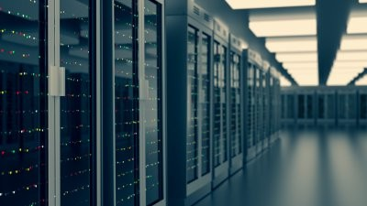

A more complete reliability picture
Compliance requirements are also moving operators toward a more coordinated approach. The 2023 edition of NFPA 70B placed greater emphasis on documented electrical maintenance and thermographic inspection. Inspection records, identified deficiencies, and corrective actions are increasingly part of the facility’s broader maintenance and audit process rather than being managed informally or in isolation.

None of this means operators need to replace systems that already work. It means they should view perimeter protection, power monitoring, interior surveillance, rack conditions, and compliance as part of a single reliability program.

Flir supports that full path, from radar and thermal detection at the perimeter to radiometric monitoring of critical equipment inside the facility. By connecting those capabilities, operators gain a clearer view of risk across the site and more time to respond before a condition escalates into an outage.

For most data center operators, the first step is not another purchase order. It is a change in perspective: seeing the path from the outer fence to the inner rack as one continuous reliability environment.

ABOUT FLIR, A TELEDYNE TECHNOLOGIES COMPANY
FLIR, a Teledyne Technologies company, is a world leader in intelligent sensing solutions for industrial applications with thousands of employees worldwide. Founded in 1978, the company creates advanced technologies to help professionals make better, faster decisions that save lives and livelihoods. For more information, please visit www.teledyneflir.com or follow @flir.

