

Flir Launches the Fixed Si2a PD Acoustic Imaging Camera for Continuous Partial Discharge Monitoring

Flir, a Teledyne Technologies brand, today announced the launch of the Flir Si2a PD, a fixed-mount acoustic imaging camera designed to deliver continuous, always-on monitoring of partial discharge (PD) in medium to high-voltage utility and industrial environments.
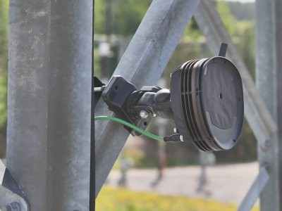
Flir, a Teledyne Technologies brand, today announced the launch of the Flir Si2a PD, a fixed-mount acoustic imaging camera designed to deliver continuous, always-on monitoring of partial discharge (PD) in medium to high-voltage utility and industrial environments.
Building on the advanced performance of Flir’s handheld Si-Series acoustic cameras, the new Si2a PD introduces the company’s first-ever permanently installed acoustic solution that continuously monitors critical assets such as substations, switchgear, transformers, and gas-insulated systems (GIS). By capturing intermittent and transient events that traditional inspections often miss, the Si2a PD helps utilities detect faults earlier and take action before they lead to failures or outages.
“Partial discharge is often intermittent and can therefore be difficult to capture during routine inspections,” said Darrell Taylor, Business Director for Acoustics. “With the Si2a PD, customers gain continuous visibility into their assets, enabling earlier detection, improved reliability, and more informed maintenance decisions.”

Continuous Monitoring for Critical Assets
The Si2a PD is designed to support proactive maintenance strategies by providing uninterrupted monitoring of electrical anomalies, including partial discharge, corona, and arcing, and ensuring that no critical event goes undetected, even during peak load conditions or outside scheduled inspections.

Key Benefits
- Prevent outages and improve reliability with early detection of PD, corona, and arcing
- Continuous 24/7 monitoring to capture intermittent faults missed by periodic inspections
- Detect, locate, classify, and assess faults from up to 200 m (656 ft)
- AI-enhanced analysis for accurate results with minimal operator intervention
- Safer, non-contact monitoring in energized environments
- Built for harsh conditions, with IP66-rated protection for outdoor substations and industrial sites

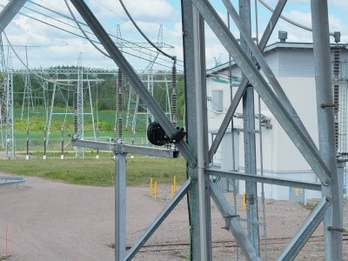

Advanced Detection and Actionable Insights
The Si2a PD is purpose-built for utility transmission and distribution networks, as well as energy-intensive industrial facilities where asset reliability is critical. It combines acoustic imaging with AI-driven detection and classification, providing clear visualization and actionable insights into asset condition. This enables maintenance teams to prioritize interventions, reduce manual inspection effort, and improve overall operational efficiency.
Integrated with the Flir AssetLink™ ecosystem, the system supports data recording, event tracking, and seamless integration into digital maintenance workflows, helping teams move from periodic inspections to continuous condition monitoring.

Availability
The Flir Si2a PD is available starting June 30, 2026. For more information, visit: https://www.flir.com/products/si2a-pd/

ABOUT FLIR, A TELEDYNE TECHNOLOGIES COMPANY
FLIR, a Teledyne Technologies company, is a world leader in intelligent sensing solutions for industrial applications with thousands of employees worldwide. Founded in 1978, the company creates advanced technologies to help professionals make better, faster decisions that save lives and livelihoods. For more information, please visit www.teledyneflir.com or follow @flir.

